**BANK LOAN REPORT SQL QUERY DOCUMENT**  
  
**A. BANK LOAN REPORT | SUMMARY**

KPI’s:

Total Loan Applications  
  
We need to calculate the total number of loan applications received during a specified period.

Additionally, it is essential to monitor the Month-to-Date (MTD) Loan Applications and track changes Month-over-Month

(MoM).

Total Loan Applications

SELECT COUNT(id) AS Total_Applications FROM bank_loan_data



MTD Loan Applications:

SELECT COUNT(id) AS Total_Applications FROM bank_loan_data

WHERE MONTH(issue_date) = 12



PMTD Loan Applications

SELECT COUNT(id) AS Total_Applications FROM bank_loan_data

WHERE MONTH(issue_date) = 11



Total Funded Amount:

SELECT SUM(loan_amount) AS Total_Funded_Amount FROM bank_loan_data



MTD Total Funded Amount

SELECT SUM(loan_amount) AS Total_Funded_Amount FROM bank_loan_data

WHERE MONTH(issue_date) = 12



PMTD Total Funded Amount

SELECT SUM(loan_amount) AS Total_Funded_Amount FROM bank_loan_data

WHERE MONTH(issue_date) = 11



Total Amount Received

SELECT SUM(total_payment) AS Total_Amount_Collected FROM bank_loan_data



MTD Total Amount Received

SELECT SUM(total_payment) AS Total_Amount_Collected FROM bank_loan_data

WHERE MONTH(issue_date) = 12



PMTD Total Amount Received

SELECT SUM(total_payment) AS Total_Amount_Collected FROM bank_loan_data

WHERE MONTH(issue_date) = 11



Average Interest Rate

SELECT AVG(int_rate)*100 AS Avg_Int_Rate FROM bank_loan_data



MTD Average Interest

SELECT AVG(int_rate)*100 AS MTD_Avg_Int_Rate FROM bank_loan_data

WHERE MONTH(issue_date) = 12



PMTD Average Interest

SELECT AVG(int_rate)*100 AS PMTD_Avg_Int_Rate FROM bank_loan_data

WHERE MONTH(issue_date) = 11



Avg DTI

SELECT AVG(dti)*100 AS Avg_DTI FROM bank_loan_data



MTD Avg DTI

SELECT AVG(dti)*100 AS MTD_Avg_DTI FROM bank_loan_data

WHERE MONTH(issue_date) = 12



PMTD Avg DTI

SELECT AVG(dti)*100 AS PMTD_Avg_DTI FROM bank_loan_data

WHERE MONTH(issue_date) = 11



GOOD LOAN ISSUED

Good Loan Percentage

SELECT

(COUNT(CASE WHEN loan_status = 'Fully Paid'OR loan_status = 'Current' THEN id

END) * 100.0) /

COUNT(id) AS Good_Loan_Percentage FROM bank_loan_data



Good Loan Applications

SELECT COUNT(id) AS Good_Loan_Applications FROM bank_loan_data

WHERE loan_status = ‘Fully Paid’ OR loan_status =’Current’



Good Loan Funded Amount

SELECT SUM(loan_amount) AS Good_Loan_Funded_amount FROM bank_loan_data

WHERE loan_status = ‘Fully Paid’ OR loan_status = ‘Current’



Good Loan Amount Received

SELECT SUM(total_payment) AS Good_Loan_amount_received FROM bank_loan_data

WHERE loan_status = ‘Fully Paid’ OR loan_status = ‘Current’



BAD LOAN ISSUED

Bad Loan Percentage

SELECT

(COUNT(CASE WHEN loan_status = ‘Charged Off’ THEN id END) * 100.0) /

COUNT(id) AS Bad_Loan_Percentage

FROM bank_loan_data



Bad Loan Applications

SELECT COUNT(id) AS Bad_Loan_Applications FROM bank_loan_data

WHERE loan_status = ‘Charged Off’



Bad Loan Funded Amount

SELECT SUM(loan_amount) AS Bad_Loan_Funded_amount FROM bank_loan_data

WHERE loan_status = ‘Charged Off’



Bad Loan Amount Received

SELECT SUM(total_payment) AS Bad_Loan_amount_received FROM bank_loan_data

WHERE loan_status = ‘Charged Off’



LOAN STATUS

SELECT

loan_status,

COUNT(id) AS LoanCount,

SUM(total_payment) AS Total_Amount_Received,

SUM(loan_amount) AS Total_Funded_Amount,

AVG(int_rate * 100) AS Interest_Rate,

AVG(dti * 100) AS DTI

FROM

bank_loan_data

GROUP BY

loan_status

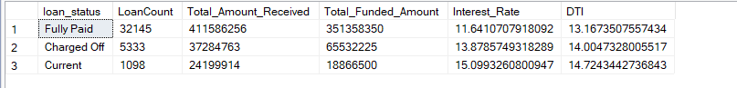

SELECT

loan_status,

SUM(total_payment) AS MTD_Total_Amount_Received,

SUM(loan_amount) AS MTD_Total_Funded_Amount

FROM bank_loan_data

WHERE MONTH(issue_date) = 12

GROUP BY loan_status

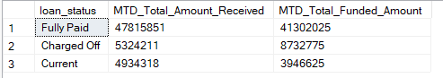

B. BANK LOAN REPORT | OVERVIEW

MONTH

SELECT

MONTH(issue_date) AS Month_Munber,

DATENAME(MONTH, issue_date) AS Month_name,

COUNT(id) AS Total_Loan_Applications,

SUM(loan_amount) AS Total_Funded_Amount,

SUM(total_payment) AS Total_Amount_Received

FROM bank_loan_data

GROUP BY MONTH(issue_date), DATENAME(MONTH, issue_date)

ORDER BY MONTH(issue_date)

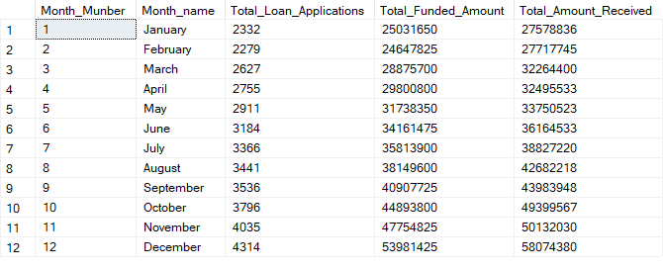

STATE

SELECT

address_state AS State,

COUNT(id) AS Total_Loan_Applications,

SUM(loan_amount) AS Total_Funded_Amount,

SUM(total_payment) AS Total_Amount_Received

FROM bank_loan_data

GROUP BY address_state

ORDER BY address_state

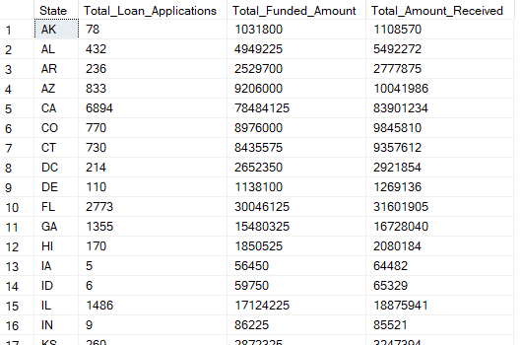

TERM

SELECT

term AS Term,

COUNT(id) AS Total_Loan_Applications,

SUM(loan_amount) AS Total_Funded_Amount,

SUM(total_payment) AS Total_Amount_Received

FROM bank_loan_data

GROUP BY term

ORDER BY term

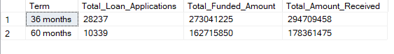

EMPLOYEE LENGTH

SELECT

emp_length AS Employee_Length,

COUNT(id) AS Total_Loan_Applications,

SUM(loan_amount) AS Total_Funded_Amount,

SUM(total_payment) AS Total_Amount_Received

FROM bank_loan_data

GROUP BY emp_length

ORDER BY emp_length

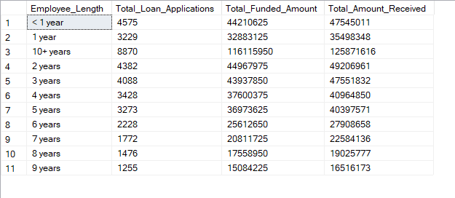

PURPOSE

SELECT

purpose AS PURPOSE,

COUNT(id) AS Total_Loan_Applications,

SUM(loan_amount) AS Total_Funded_Amount,

SUM(total_payment) AS Total_Amount_Received

FROM bank_loan_data

GROUP BY purpose

ORDER BY purpose

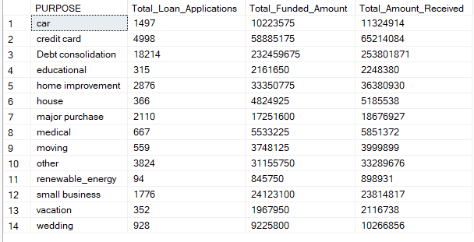

HOME OWNERSHIP

SELECT

home_ownership AS Home_Ownership,

COUNT(id) AS Total_Loan_Applications,

SUM(loan_amount) AS Total_Funded_Amount,

SUM(total_payment) AS Total_Amount_Received

FROM bank_loan_data

GROUP BY home_ownership

ORDER BY home_ownership

